Chapter 18
Post-harvest Contamination
Table 1. A partial list of post harvest fungi that affect Cannabis. All of these may cause losses due to rot and spore contamination. Some of these fungi pose human health threats as producers of mycotoxins or as direct human pathogens.

Kingdom: | Fungi | Fungi | Fungi | Fungi | Fungi
Phylum: | Ascomycota | Ascomycota | Ascomycota | Ascomycota | Mucoromycotina
Class: | Leotiomycetes | Eurotiomycetes | Eurotiomycetes | Sordariomycetes | Zygomycetes
Order: | Helotiales | Eurotiales | Eurotiales | Hypocreales | Mucorales
Family: | Sclerotiniaceae | Trichocomaceae | Trichocomaceae | Nectriaceae | Mucoraceae
Genus: | Botrytis | Aspergillus | Penicillium | Fusarium | Rhizopus
Species: | Botrytis cinerea | Aspergillus flavus, A. niger, | Penicillium citrinum, P. paxilli, P. commune, P. copticola | Fusarium oxysporum,  F. solani, F. equiseti | Rhizopus stolonifer

After Cannabis plants are harvested, they’re not just at risk for fungal infections while still alive, but also after they’ve been cut down. Improper drying, curing, or storage can lead to fungal growth on your flowers or concentrates. Common offenders include moldy fungi like Aspergillus, Penicillium, and Rhizopus, which are all pretty widespread and can be found in most environments. As the Cannabis industry continues to grow, we’ll probably see more regulations and testing for these types of fungi in Cannabis products.
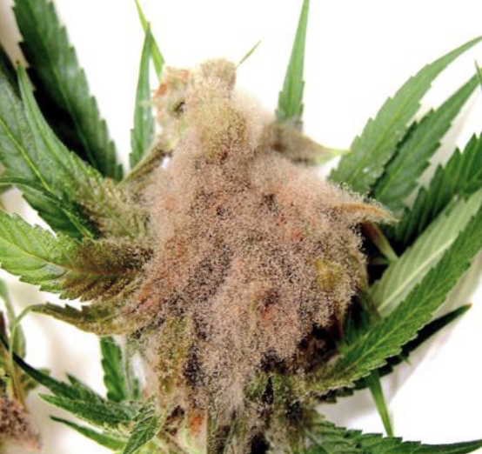
Figure 18.1. Filamentous mold (B. cinerea) growing and sporulating on mature Cannabis flower. Mahmoud et al 2023.
For fungi to grow, moisture is essential. So, if there’s enough water content in your Cannabis, whether it’s flowers, concentrates, or even edibles, those microbial invaders can thrive. That’s why it’s so important for growers to be careful with how they dry, cure, and store their Cannabis products, especially flowers and ice-water hash. Too much moisture or high water potential means fungi will have the perfect conditions to grow. Ideally, dried Cannabis flowers should have about 10-15% moisture content when they’re ready for consumption. With this amount of moisture, the product won’t be too dry or crumbly, and it’ll still retain its aroma, but there won’t be enough moisture for fungi to grow.
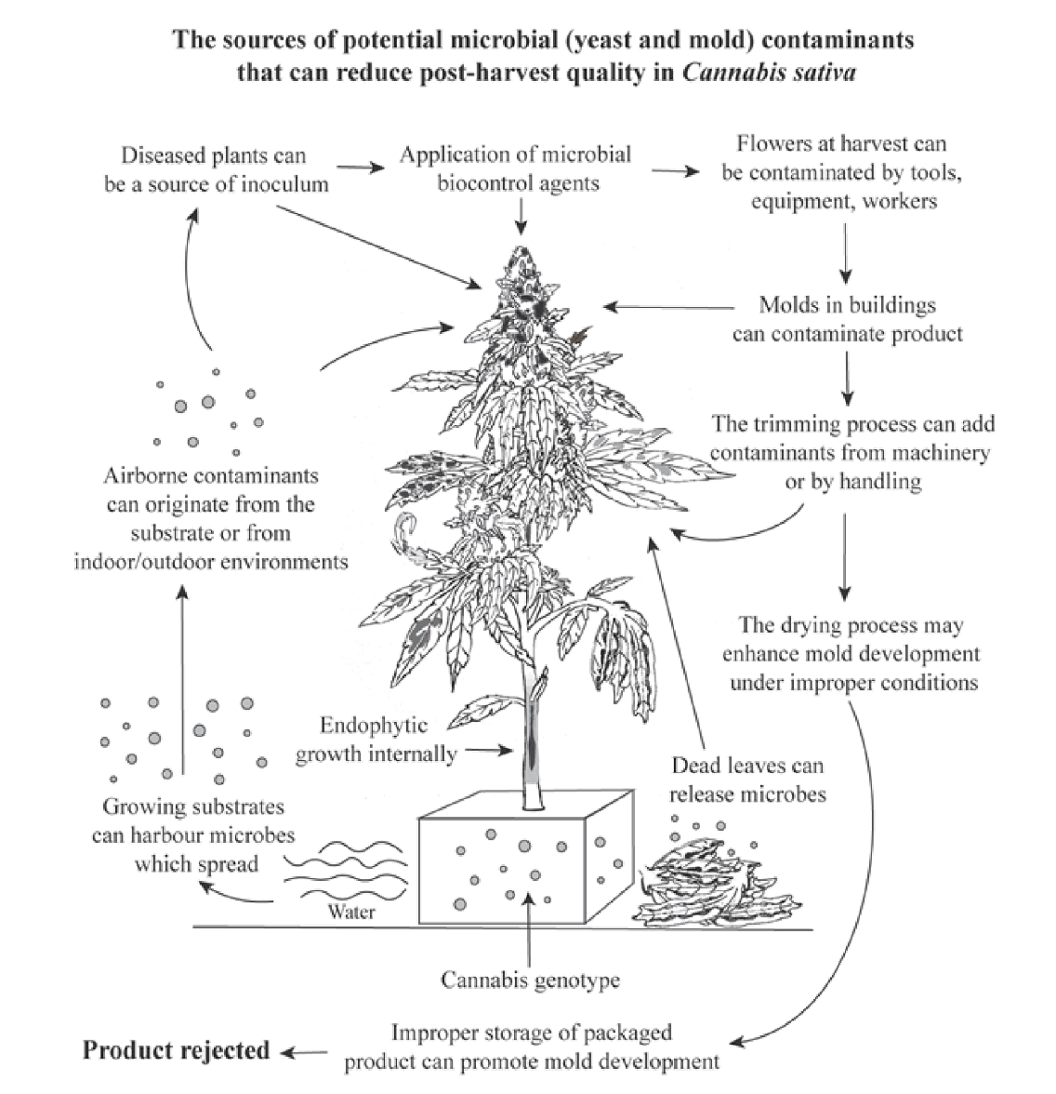
Fig 18.2 Potential sources of Cannabis flower contamination post harvest. Punja et al 2023.

If the flowers are dried and stored properly, they can last for a long time with very little risk of mold. As long as moisture doesn’t get added back to them, the fungi won’t have much of a chance. Glass jars with tight-fitting lids are great for long-term storage on a small scale. On a larger scale, airtight buckets (like 5 or 55 gallons) can be used, especially if stored in cold temperatures or buried underground to keep things cool. For extra shelf life, some growers use nitrogen gas to purge the air from storage containers, which helps slow down oxidation.
Table 18.2. Water activity is a measure of vapor pressure within drying Cannabis flowers divided by the partial vapor pressure of water at the same temperature.
aw=p/p*
aw= water activity | p= partial vapor pressure within the flower | p*=partial vapor pressure of water at a given temperature

Now, the first few days after harvest are a critical time for mold growth, but if the moisture in the flowers drops quickly enough, the risk of mold will be minimized. This is where measuring water activity becomes important. Water activity (often abbreviated as aw) measures how much free water is available for microorganisms to use. It’s different from moisture content, which just tells you how much water is in the material as a percentage of its weight.
Water activity is measured on a scale from 0 to 1, where 0 is completely dry and 1 is pure water. Most fungi need an aw of over 0.7 to grow, so Cannabis flowers should reach an aw of 0.8 as quickly as possible, ideally within a few days. After that, drying should continue slowly at a cool temperature for several weeks. Once the flowers hit an aw of 0.6, they’re ready for curing. Some states like Oregon, Colorado, and California even have regulations requiring flower to have an aw below 0.65 to prevent spoilage.
Table 18.3 Water content benchmarks through the drying process.
Stage | Water activity (preferred) | Moisture content⁴
fresh | >0.9 | 90%
drying | <0.8-0.65 | <16-12%
curing | 0.7-0.6 | 12-11%
storage/use | <0.65-0.6 | <12-10%

For more precise control, growers use water activity monitors, which can range from a few hundred to several thousand dollars, but these are essential for those who need exact measurements. However, moisture content can be checked more cheaply at home. You can weigh a sample of fresh Cannabis, dry it out completely in an oven or dehydrator, and then reweigh it. By comparing the difference in weight, you can calculate the moisture content easily.
Table 18.3. How to measure the moisture content of Cannabis flower.

- Weigh out 100g of flower
- Heat oven to lowest temperature (<200ºF)
- Put flower in oven for 2 hours
- Remove from oven and re-weigh material
- ((Fresh Weight - New weight)/Starting Weight) X 100%=Moisture content

Eg. I have a 100 g sample of Cannabis flower. After dehydrating the sample, the flower weighs 85 grams:

((100-85)/100) X 100%= Moisture content
(100-85)=15
((15)/100) X 100%=MC
(.15) X 100%=MC
Moisture Content=15%

In terms of drying environment, the typical rule is to keep the room at 60% relative humidity or lower, with temperatures below 60°F. However, sometimes this can leave too much room for mold growth, so it can be helpful to drop the relative humidity even lower during the early stages of drying. Using circulating fans will help avoid stagnant air pockets, and cooler temperatures will keep the fungi at bay. This will also help maintain the flower’s quality while it dries slowly, leading to a smoother, more aromatic final product.
Table 18.4 Environmental parameters for drying Cannabis flower to ensure no loss to mold post-harvest
Relative humidity | <60%
Temperature | ~<60oF
Air movement | Steady movement, no still pockets
Lighting | Kept Dark

There’s a bit of debate about what exactly happens during the drying and curing process of Cannabis. While we know there are chemical changes that take place after the plant is harvested, there’s not a ton of research specific to Cannabis. Tobacco, on the other hand, has been studied more due to legal reasons. In tobacco curing, for example, chlorophyll and starches break down while sugars increase (Yamaguchi et al. 2013). Several reactions occur in the process, such as the Maillard reaction between amino acids and sugars, the formation of nitrosamines from nicotine and nitrates, and the breakdown of phenylalanine, which leads to the production of volatile phenols. There’s also oxidation of isoprenoids and carotenoids (Zhu et al. 2016).
Farmers often focus on terpene content throughout the growing and drying stages, but a whole range of other chemical compounds also come into play, like phenols, acetyls, ketones, thiols, and esters. These all work together to create the final scent of Cannabis. As the flower dries and cures, its chemical profile continues to develop. For instance, oxidation of carotenoids (which are tetraterpenoids) produces "rose ketones" like ionones and damascones. These compounds are key to the distinct scent of roses (Yue et al. 2016).
Freeze-drying has been getting attention as a method for drying Cannabis while preserving its quality. Since terpenes and other volatile compounds play a big role in the sensory experience, freeze-drying could be one of the best ways to preserve them. Plus, because the process is fast and done at low temperatures, it reduces the risk of mold growth compared to traditional slow-drying methods.
If the smokeability or overall quality of your final product, adding some heat during the drying process might be worth considering. On a larger scale, some hemp farms that focus on CBD extraction have adapted large hops dryers for Cannabis, allowing them to process huge quantities of biomass. For products like vaporizer pen cartridges, most of the material comes from distillates or isolates, so the original flower quality doesn’t matter as much (though healthier plants will likely have more cannabinoids). For operations that process flowers without purifying them into isolates, though, mold can concentrate mycotoxins, which can be problematic.
If you find mold on your flower after it’s dried, even if you followed the right drying parameters, it's likely that the mold was already growing while the plant was alive. Some fungi, like Aspergillus or Penicillium, can be sneaky and go unnoticed by growers. These fungi are often endophytes (living inside the plant) or latent saprophytes (living off dead tissue).
Most fungi that affect Cannabis aren’t harmful to humans. This includes common molds like Botrytis and powdery mildew (Erysiphales), though inhaling large amounts of spores could cause respiratory issues or trigger allergic reactions in some people. What’s more concerning, however, is that some fungi on Cannabis can produce mycotoxins or even cause human diseases. Certain species of Aspergillus and Penicillium, which are known to produce toxic compounds, can grow on Cannabis as contaminants or endophytes (Mckernan et al. 2015; Taghinasab & Suha Jabaji, 2020). Other fungi, like Cryptococcus and Mucor, which can cause diseases in humans, have also been found on Cannabis intended for human consumption (Thompson et al. 2017; B. Shapiro et al. 2018; Scott et al. 2018).

Mycotoxins

Mycotoxins are a group of compounds produced by fungi that are toxic to those that consume them. Often mycotoxins remain in a particular material (eg. Cannabis flower) long after the fungus has been eradicated.Therefore these chemicals can be quite insidious, commonly avoiding detection.

There are a number of fungal species that produce mycotoxins in Cannabis products and many are found in the genus Fusarium, Aspergillus, or Penicillium. Examples of mycotoxins reported from Cannabis include aflatoxins, T-2 toxins, ochratoxins and trichothecenes. (Gwinn et al. 2023)

Most of these toxic compounds are produced by pathogenic fungi but some can be produced by fungi that are not causing disease symptoms in the host plant.

Luckily, some mycotoxins are destroyed and denatured at temperatures greater than 356oF, whereas cannabis is typically consumed at temperature ranges from 500-700oF (Gwinn et al 2023). However, consuming cannabis tainted with mycotoxins is never recommended, especially for immune-compromised people.

Extraction of mycotoxin-contaminated Cannabis flowers can actually concentrate these compounds, creating even more dangerous products. Therefore proper testing and regulation should be implemented to avoid any potential risk.

Aspergillosis is a disease caused by certain species of the Aspergillus genus. It results in a serious pulmonary infection where fungal mycelium grows in the lungs, and in some cases, it can be fatal. There have been reports of deaths related to Aspergillus-contaminated Cannabis, particularly in people with compromised immune systems (Gargani et al., 2011; Remington et al., 2015). In severe cases, the fungus can form a 3D colony called a "fungus ball" in the lungs, which can invade nearby tissue. Exposure to moldy Cannabis has also been linked to allergic bronchopulmonary aspergillosis, which is an autoimmune response to different Aspergillus species (Llamas et al., 1978).
Aspergillus spores are everywhere in the environment, so you're probably inhaling them right now. For most people with a healthy immune system, these spores don’t cause any issues. However, moldy Cannabis can contain such a high concentration of spores that it can overwhelm even healthy individuals, or trigger severe immune reactions in people with allergies. There’s even been a case where a healthy, non-immunocompromised person who smoked Cannabis regularly was linked to developing cryptococcal meningitis, potentially due to exposure to spores from the flower (B. Shapiro et al., 2018).
Another dangerous fungal infection is mucormycosis, which is caused by fungi in the Rhizopus and Mucor genera. This can lead to severe disfigurement or even death. Some cases of mucormycosis have been linked to medical Cannabis use in diabetic patients (Stone et al., 2019). Additionally, for people who are severely immunocompromised, fungi that usually don’t cause disease in healthy individuals, like Fusarium species, have been known to cause fatal lung infections when inhaled through Cannabis use (Khwaja et al., 2016). One of the most common fungi found on Cannabis in California dispensaries is Purpureocillium, an emerging human pathogen that can cause lung infections (Thompson et al., 2016; Salazar-González et al., 2020). Because of these serious health risks, it’s crucial for Cannabis products to be tested for harmful fungi and grown and processed in ways that minimize contamination.
Microbial testing for Cannabis varies by state. Some states don’t do any microbial testing at all but instead measure things like water activity and moisture content to predict how likely microbes are to grow on the plant material. However, there aren’t yet standardized methods to definitively detect harmful pathogens, and distinguishing them from harmless microbes remains a challenge. As the industry grows, testing methods will likely become more accurate and rigorous. Species-specific tests, such as metabolic or DNA sequencing-based assays, are being developed for Cannabis samples. Until these tests are more widespread, we have to rely on imperfect screening methods and our own senses when checking products before consumption. If there’s any doubt about contamination, or if you’re immunocompromised, extra caution should be taken.
There are post-harvest sterilization options available for Cannabis products. Various extraction and purification methods can recover cannabinoids and terpenes from contaminated flower. While it's harder to ensure that unprocessed flower is completely free from microbial risks, clean extracts are much easier to achieve. Unfortunately, most of the flower remediation methods available to small-scale growers can degrade the quality of the product. Commercial sterilization products, commonly used in the food industry, cause less damage to the quality but can be prohibitively expensive (Table 5).
Table 18.5. Sterilization methods for Cannabis flower. Radio frequency and e-beam radiation have both been reported to remediate Cannabis flower without unacceptable losses in quality.
Category | Method | Benefits | Negatives
Extraction | hydrocarbon, alcohol, CO2, distillation | - Accessible to all scales  - Produces high quality extract product | - Flower may be a preferable product  - Some infrastructure investment and knowledge required  - May concentrate pesticides and mycotoxins
Heat treatments | Steam, autoclave, pressure cooker, dry oven | - Highly effective at destroying nearly all biological contaminants | - Destroys flower  - Degrades and alters cannabinoid content
Non-ionizing radiation | Microwave, Radio frequency | - Capable of sterilization throughout an entire flower sample, not just the surface  - Much less damaging than direct heat treatments | - Degradation in organoleptic qualities still occurs, including losses of terpenes
Ionizing radiation | Gamma, X-ray, electron-beam | - Capable of sterilization throughout an entire flower sample, not just the surface  - Much less damaging than direct heat treatments | - Degradation in organoleptic qualities may still occur, including losses of terpenes  - Gamma radiation requires dangerous radioactive material

Some consumers may be particularly sensitive to any reduction in quality, while others may prioritize eliminating pathogen risks entirely. Farmers need to think about the needs of different consumers across the market, including those who require sterile products. In some regions, there are regulations that set minimum standards for microbial contamination, and in areas where yeast and mold counts are used as the measure (instead of testing for specific pathogens), post-harvest remediation may be required—especially for outdoor crops that are exposed to higher levels of environmental spores, and where air filtration or sterilization isn’t feasible.
It’s important to use your senses when inspecting Cannabis before consuming it. Look for any fuzzy or furry growth on the flower, which could indicate the presence of mold. If the bud feels unusually dry and crumbly, or on the other hand, it feels soft and tears instead of snapping, that could also signal fungal contamination. If the flower doesn’t feel right, take a closer look before using it.
Eventually, you might even be able to see spore-bearing structures (called conidia) forming on the flowers. These can sometimes look a lot like trichomes, so you may need magnification to tell the difference. Using a jeweler's loupe or a dissecting microscope can help you spot mold from the desirable trichomes (Fig. 2). If conidia are well-developed, you may see a cloud of spores when you break apart a bud. While trichomes will fall straight down because of gravity, spores tend to rise up in the air, looking like a puff of smoke.
You can also try sniffing the flower for any moldy smells. Mold releases volatile organic compounds that usually have a foul, musty scent. If the flower smells damp or off, that could be a sign that it’s contaminated with mold and should be discarded.
In summary:
- Even after harvesting cannabis plants there are a number of fungal species that can destroy Cannabis flowers if not dried and stored properly
- Reducing water activity in final products can ensure no fungal growth can occur
- Best practice is to store properly dried cannabis flowers in glass jar in the dark kept around 65oF with little fluctuation

